**“ONLINE FOOD ORDERING SYSTEM ”**

**A Project report submitted**

**In the partial fulfillment the award of degree of BACHELOR OF TECHNOLOGY**

**IN**

**COMPUTER SCIENCE AND ENGINEERING (2022-2023) BY**

**A.MAHESH Reg.No:211801340019**

**Under the esteemed Guidance of**

**Mrs. G. Rama Devi, M.Tech,(Ph.d),Asst. Professor**



**CENTURION UNIVERSITY SCHOOL OF ENGINEERING AND TECHNOLOGY**

**Rollavaka village, Tekkali mandal 535003 (2022-2023)**

**CENTURION UNIVERSITY OF TECHNOLOGY AND MANAGEMENT**

**ANDHRA PRADESH**

**(2019-2023)**

**DEPARTMENT OF COMPUTER SCIENCE AND ENGINEERING**



BONAFIDE CERTIFICATE

This is to certify that the project work entitled “ONLINE FOOD ORDERING SYSTEM ” is a fulfillment of project work done by A.MAHESH(211801340019)for the award the degree of BACHELOR OF TECHNOLOGY in COMPUTER SCIENCE AND ENGINEERING, CENTURION UNIVERSITY OF TECHNOLOGY AND

MANAGEMENT, during the academic year 2022-2023.

INTERNALGUIDE HEAD OF THE DEPARTMENT

Mrs .G. Rama Devi Mr.R. Lakshmana Rao

**Asst. Professor Asst. Professor**

**Dept. of CSE Dept. of CSE**

**EXTERNAL EXAMINER**

**ACKNOWLEDGEMENT**

It is with at most pleasure and excitement we submit our project partial fulfillment of the requirement for the award of Bachelor of Technology.

The project is a result to the cumulate efforts, support, guidance, encouragement and inspiration from many of those for whom we have to give our truthful honor and express gratitude through bringing out this project at the outset as per our knowledge.

I convey my special thanks to our project **Guide Mrs. G. Rama Devi(Asst. Professor)** who has guided, encouraged and tremendously supported me to enhance my knowledge with present working of this project to bring out enriching the quality of project.

I express my appreciativeness to **Mr. R.LAKSHMAN RAO(Asst. Professor) and Head of the Department,** who facilitated us to providing the friendly environment which helped to enhance my skills in present project.

I would also like to extend my gratitude to **Dr. K. V. G. KRISHNA MURTHY, Dean- School of Engineering And Technology, Centurion University of Technology and Management** who has helped us to attain all the requirements of the project.

I convey my sincere thanks to **Dr. RAMANA RAO, Ph. D Registrar of Centurion University of Technology and Management** who provided us with an opportunity to take on project work in well-equipped laboratories of Computer Science Department in our college.

At the outset, we thank to **Sri. G.S.N.RAJU**, beloved **Vice Chancellor of Centurion University of Technology and Management** who is the back bone by providing for completion of this project, Thank you sir.

**DECLARATION**

I hereby declare that the project entitled **“ONLINE FOOD ORDERING SYSTEM”** submitted to the fulfillment of award the degree of **B.TECH (CSE)** in **CENTURION UNIVERSITY OF TECHNOLOGY AND MANAGEMENT**, **ANDHRA PRADESH.**

**A.MAHESH Reg.No:211801340019**

# TABLE OF CONTENT

ABSTRACT i

1. INTRODUCTION 01
   1. Introduction 01
   2. Objectives… 02
   3. Needs of Online Food Order 02
   4. Features 03
2. METHODOLOGY 06
   1. Complete Visualization of Online Food Ordering System 06
   2. Methodology Development Model 11
   3. System Model Design 12
   4. Admin workflow Process 13
   5. Customer Workflow Process 14
   6. Diagrams 15
      1. Schema Diagram 15
3. SOFTWARE REQUIREMENTS
   1. DEVELOPERS RESPONSIBILITES OVERVIEW 16
   2. FUNCTIONAL REQUIRENENTS 16.
   3. FUNCTIONAL REQUIREMENTS 16
      1. OUTPUT DESIGN 16
   4. OUTPUT DEFINITION 16
   5. PERFORMANCE REQUIREMENTS 16
   6. WHY MySQL 17
   7. XAMPP 17
   8. PHPAPPLICATION 17

3.

1. ANALYSIS , RESULT & DISCUSSION 19
   1. System implementation plan 19
      1. Project Planning 19
   2. Facing Problem During Development the Project 20
2. Login Page 21
   1. Signup page 21
3. Advantages 24
   1. Result & Discussion 24
   2. Application 24
4. CONCLUSION & FUTURE WORK 25
   1. Conclusion 25
   2. Frame work 26

REFERENCES 27

**INTRODUCTION**

## INTRODUCTION

**Online food ordering** is the process of ordering food from a website. The product can either be food that has been specially prepared for direct consumption (such as vegetables straight from a farm or garden, frozen meats, etc.) or food that has not been (such as direct from a certified home- kitchen, restaurant). The effort to create an online food ordering system aims to replace the manual method of taking orders with a digital one. The ability to rapidly and correctly create order summary reports whenever necessary is a key factor in the development of this project.

The potential of an online food ordering system is enormous. Any restaurant or fast food chain can use this PHP project to keep track of customer orders. This project is simple, quick, and precise. There is less disk space needed. MYSQL Server is used as the backbone by the online food ordering system, eliminating the risk of data loss and ensuring data security. Customers have the option of either having the food delivered or picked up. A customer starts by selecting the restaurant of their choice, then scans the menu, picks an item, and then decides whether they want it delivered or picked up. Then, when picking up the food, you can pay with cash at the restaurant or with a credit card or debit card using the app or website. The customer is informed by the website and app about the food's quality, how long it takes to prepare, and when it will be ready for pick- up or delivery.

## Objectives

The management of the information regarding item category, food, delivery address, order, and shopping cart is the system's primary goal. It oversees the management of all customer, shopping cart, and item category information. Since the project was entirely developed on the administrative end, only the administrator is assured access. The goal is to develop an application program to simplify managing the food consumer item category. It keeps note of every delivery address requested.

## Needs of Online Food Order

Helping customers in placing meal orders whenever they want. Customers will be able to order their preferred foods at any time, but as we've already mentioned, this is only a limited option. As a result, restaurants need to have a specific system in place that will allow them to serve a large number of customers while streamlining operations. One of the best platforms is ordering, which offers all of these services in addition to a host of cutting-edge features that have helped countless small and large enterprises establish themselves as market leaders.

## Features

* + - Based on products and components.
    - Easily creating and altering issues.
    - Issue List can be queried in any detail.
    - Reporting & Charting in a more thorough manner.
    - User accounts are used to manage access and uphold security.
    - Straightforward status & resolutions.
    - Priorities and severity levels at various levels as well as targets and milestones for the programmers to follow.
    - Attachments & Additional Comments for more information.
    - A solid database back end.
    - Various levels of reports are provided with many filtering options.

# METHODOLOGY

## Complete Visualization of Online Food Ordering System

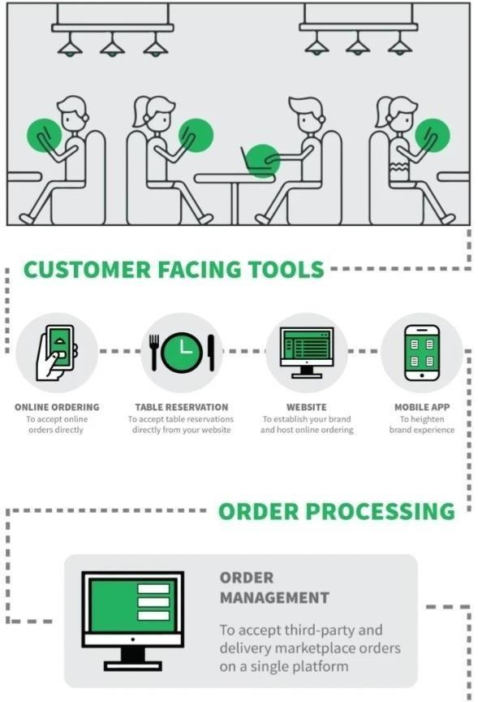An easy-to-use table management system will also be included in a good restaurant reservation setup. This enables restaurants to see their restaurant hour by hour and receive reservations through a variety of ways.

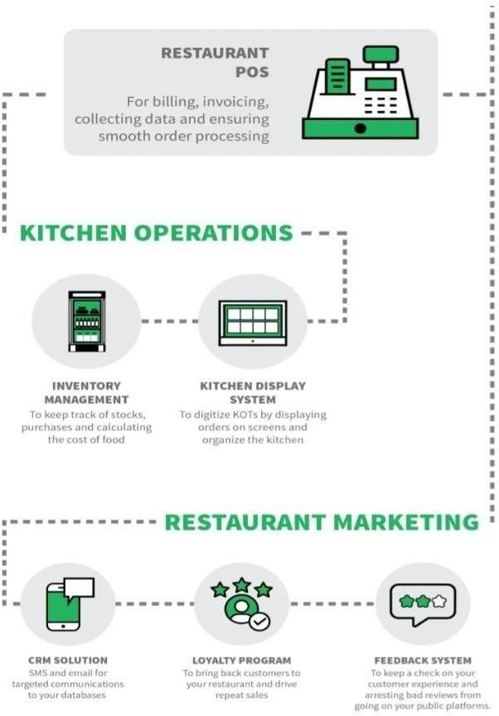

## Methodology Development Model

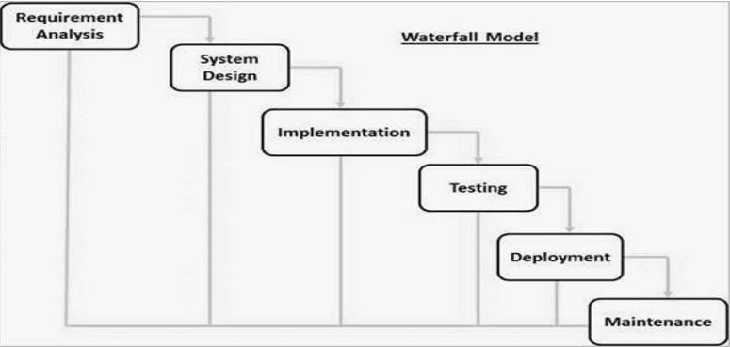

Figure 3.3.1: Methodology Development Model.

The Waterfall model's consecutive phases are:

**Requirement Gathering and analysis −** During this stage, all potential system needs are gathered and outlined in a requirement specification document.

* + - **System Design −** The system design is created in this phase after studying the requirement specifications from the first phase. This system design aids in determining the overall system architecture as well as the hardware and system requirements.
    - **Implementation −** The system is initially built in discrete programs known as units, which are then combined in the following phase, using inputs from the system design. Unit testing is the process of developing and evaluating each unit for functionality.
    - **Integration and Testing −** Following the testing of each unit created during the implementation phase, the entire system is merged. The entire system is tested for errors and failures after integration.
    - **Deployment of system −** Once the product has undergone functional and non-functional testing, it is either published to the market or deployed in the customer's environment.
    - **Maintenance −** Various problems can arise in a client environment. Patches are published to address certain problems. Additionally, improved versions of the product are issued. To bring about these changes in the surroundings of the consumer, maintenance is performed.

## System Design Model

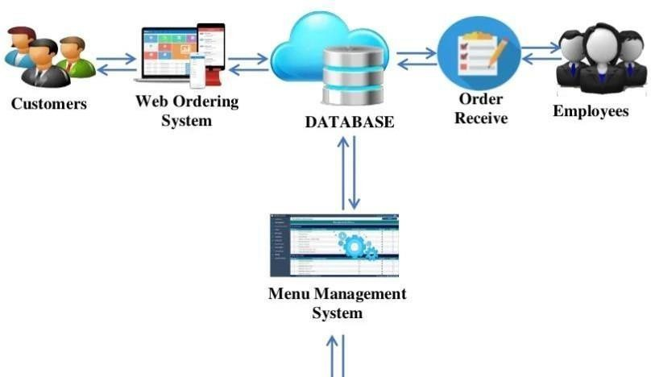

Figure 3.4.1: System Model Design

## Admin workflow Process

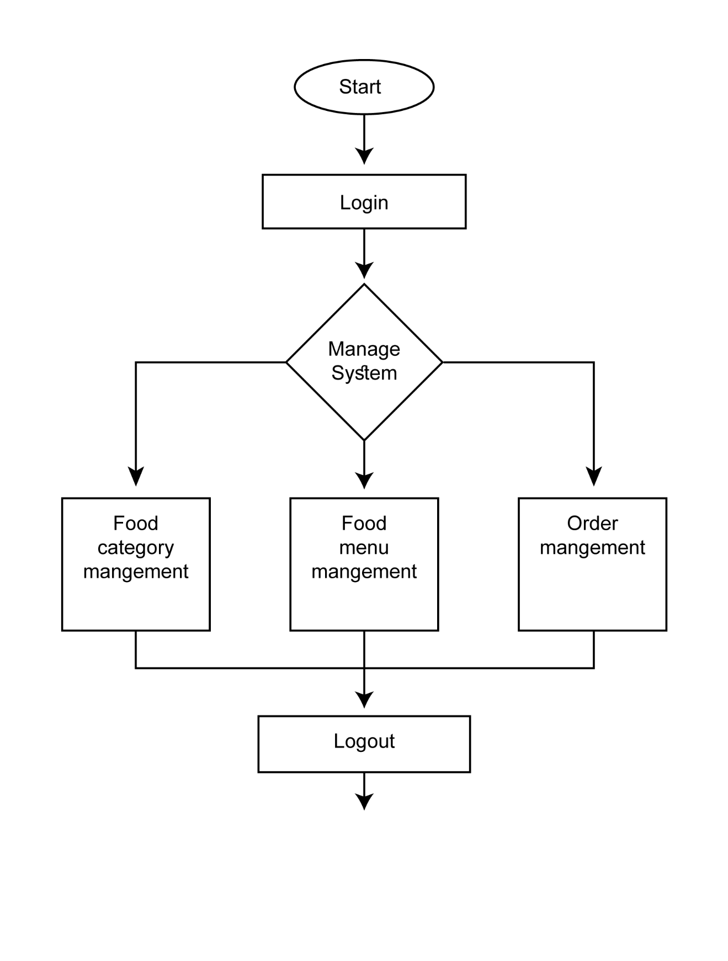User goes to home page of the domain. If he/she has an account then he/she can login in restaurant management system otherwise he/she need to register an account after successful registration, they can login in home page.

Figure 3.5.1: Admin workflow Process

13

## Customer Workflow Process

Initially to visit the food categories or food menu, users don’t need to login/register an account. After checking out the categories and menu items, if the user finds his/her desired menu and if they want to order that particular item they can go to order page. During placing any order the customer needs to provide his/her required information mentioned the order section.

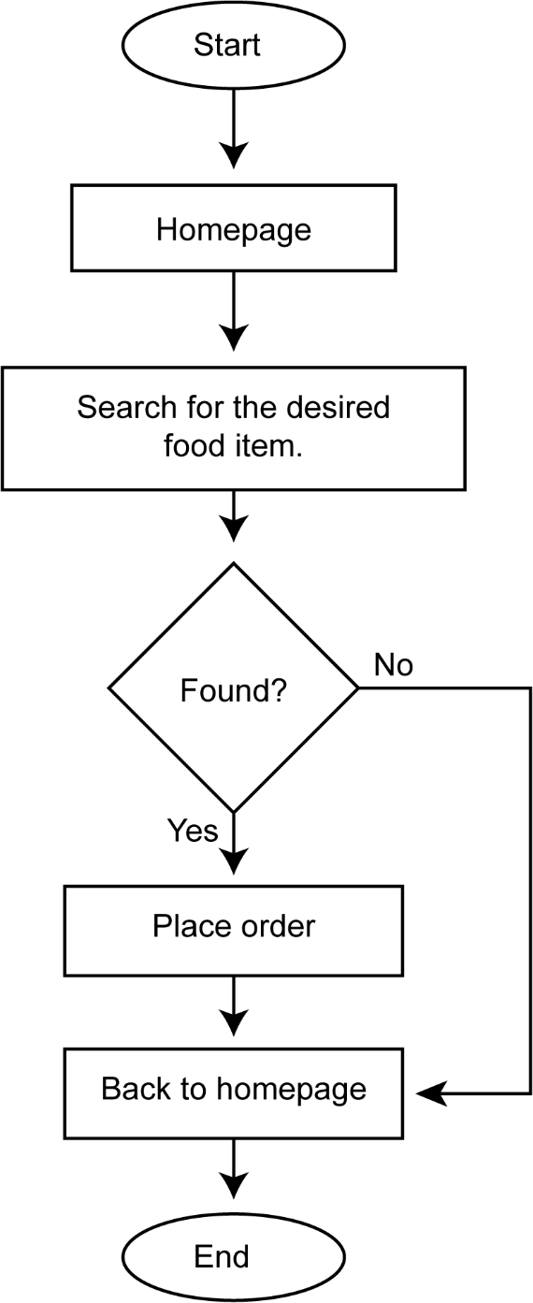

## Schema Diagram

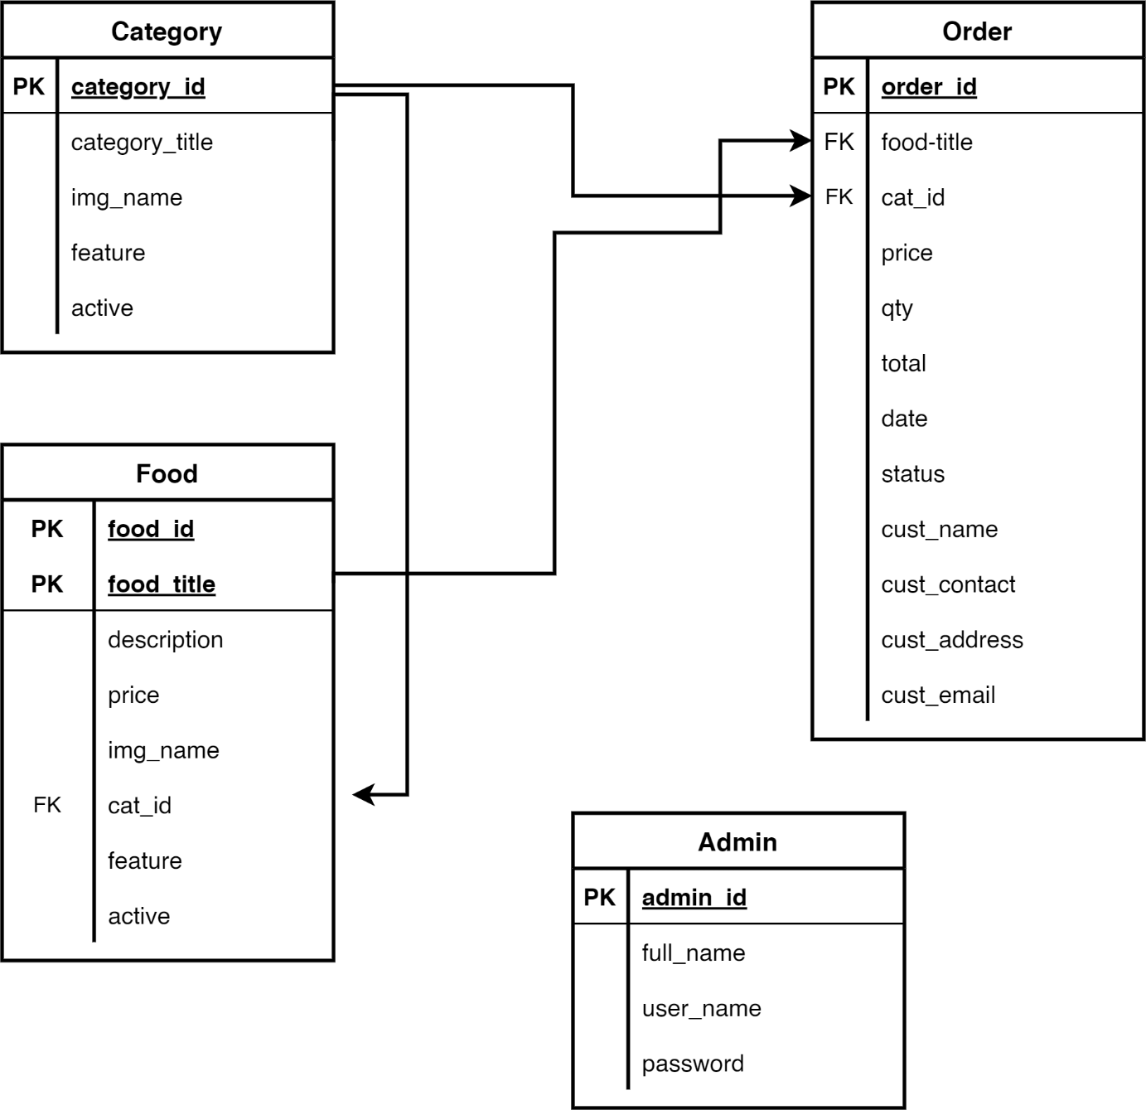

Figure 3.7.1.1 : Schema Diagram.

## SOFTWARE REQUIREMENT SPECIFICATION

* 1. **DEVELOPERS RESPONSIBILITIES OVERVIEW**: The developer is responsible for: • Developing the system, which meets the SRS and solving all the requirements of the system? • Demonstrating the system and installing the system at client's location after the acceptance testing is successful. • Submitting the required user manual describing the system interfaces to work on it and also the documents of the system. • Conducting any user training that might be needed for using the system. • Maintaining the system for a period of one year after installation.

## FUNCTIONAL REQUIREMENTS

* + 1. **OUTPUT DESIGN**

Outputs from computer systems are required primarily to communicate the results of processing to users. They are also used to provides a permanent copy of the results for later consultation. The various types of outputs in general are:

* External Outputs, whose destination is outside the organization.
* Internal Outputs whose destination is within organization and they are the
* User’s main interface with the computer.
* Operational outputs whose use is purely within the computer department.
* Interface outputs, which involve the user in communicating directly.

## Output Definition

The outputs should be defined in terms of the following points:

* Type of the output
* Content of the output
* Format of the output
* Location of the output
* Frequency of the output
* Volume of the output
* Sequence of the output
* Will decimal points need to be inserted
* Should leading zeros be suppressed.

## PERFORMANCE REQUIREMENTS

Performance is measured in terms of the output provided by the application. Requirement specification plays an important part in the analysis of a system. Only when the requirement specifications are properly given, it is possible to design a system, which will fit into required environment. It rests largely in the part of the users of the existing system to give the requirement specifications because they are the people who finallyuse the system. This is because the requirements have to be known during the initial stages so that the system can be designed according to those requirements. It is very difficult to change the system once it has been designed and on the other hand designing a system, whichdoes not cater to the requirements of the user, is of no use. The requirement specification for any system can be broadly stated as given below:

* The system should be able to interface with the existing system
* The system should be accurate
* The system should be better than the existing system The existing system is completely dependent on the user to perform all the duties.

## Why MySQL:

MySQL is a relational database management system based on SQL- Structure Query Language. The application is used for a wide range of purposes, including data warehousing, ecommerce and logging applications. The most common use for MySQL is for the purpose of a web database. MySQL creates a database for storing and manipulating data, defining the relationship of each table. Clients can make request by typing specific SQL statements on MySQL. Advantages:

* MySQL is more secure.
* MySQL is available for free to download and use from the official site of MySQL.

## XAMPP: XAMPP

is a free and Open-source cross-platform Web Server Solution Stack built by Apache Friends, which consists mostly of the Apache HTTP Server, MariaDB/MySQL Database, and interpreters for php and Perl scripts. As most real- world web server deployments share the same components as XAMPP, moving from a local test server to a live server is simple. 9.7 PHP Application The actual program that will perform the operations is written in PHP. All data will be database

## 2.7 Database Design

Database design is the management of information using a database paradigm. What data must be saved and how the various data items interact are determined by the database design that follows. Developer would start adjusting the data to the database model using this knowledge. Data classification and relationship discovery are key components of database design.

# ANALYSIS RESULT & DISCUSSION

## System Implementation Plan

A software design pattern called Model View Controller, or MVC as it is more formally known, is used to build online applications. There are three components to the Model View Controller pattern:

* + - Model - The lowest level of the pattern, is in charge of maintaining the data.
    - View - This is in charge of showing the user all or part of the data.
    - Controller - The computer program that controls how the Model and View interact. MVC is well-liked because it provides for duty separation by separating the application logic and user interface layers. The Controller accepts all requests from the application and collaborates with the Model to prepare any necessary data for the View. The View then constructs a final presentable response using the data produced by the Controller. The following is a graphic representation of the MVC abstraction. Model of MVC (Model View Controller Flow)

## 4.1.1 Project Planning

Here is an illustration of a software project plan: 1) How will the project be carried out within the company? What are the time, financial, and human resource limitations? What does having a market strategy entail? 2) Customer meetings: Weekly or as needed customer meetings that include a progress report presentation. .

The steps listed below can be used to create successful software projects: Select a project. The aims and objectives of project are as follows:

* + - * Understanding specifications and requirements.
      * Using analysis, design, and implementation methods.
      * Using testing procedures.
      * Documenting.
      * Budget allocation or exceeding limits under control.
      * Understanding project milestones and deliverables
      * Project estimates.
      * Cost and Time.

## Facing Problem During Development the Project

During the construction of the web application "Online Food Order," the developer ran into a few issues. Here are a few issues in brief:

1. **Requirement Gathering Phase:** It is a crucial step. The project will fail if the requirements are poor. At that time, developer became disappointed when Developer was collecting information and data then what information and data will be helpful or appropriate for this project.
2. **During Design Phase:** At this moment, the developer struggled to decide which flowchart would be best for this project when creating it.
3. **Development Phase:** It is a very major component of the undertaking. Frequently, the developer misplaced the semicolon (;) at the conclusion of the statement.
4. **Testing Phase:** It is an essential component of the project. This section will aid with project testing overall. During testing, developer has faced some bugs of the project.

## SYSTEM DESIGN

* 1. **LOGIN PAGE**

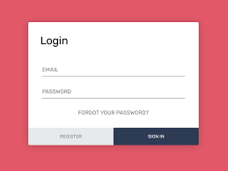

## =

* 1. **SIGNUP PAGE**

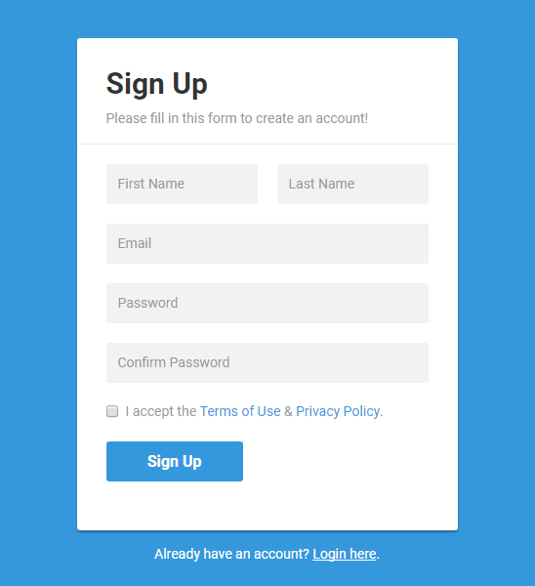

## FINAL OUTPUT

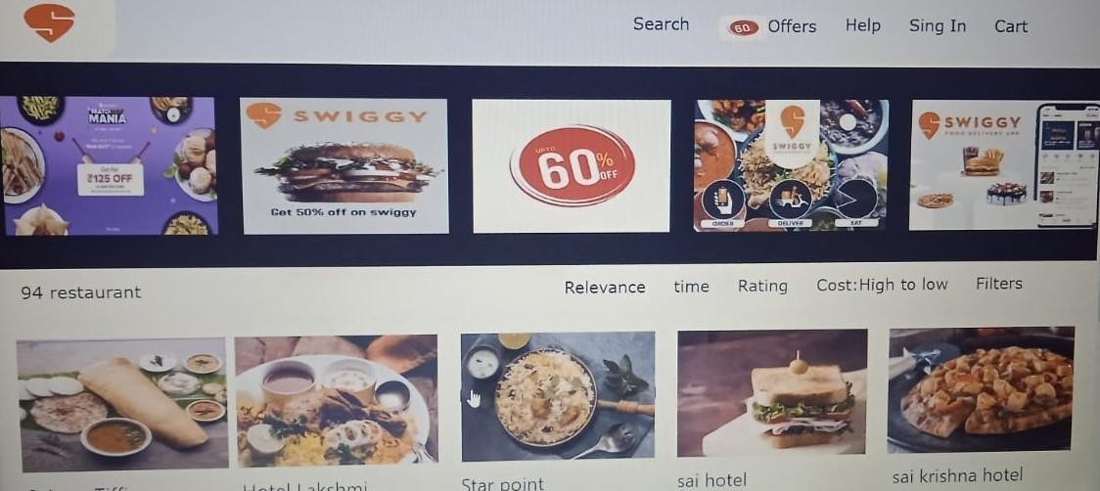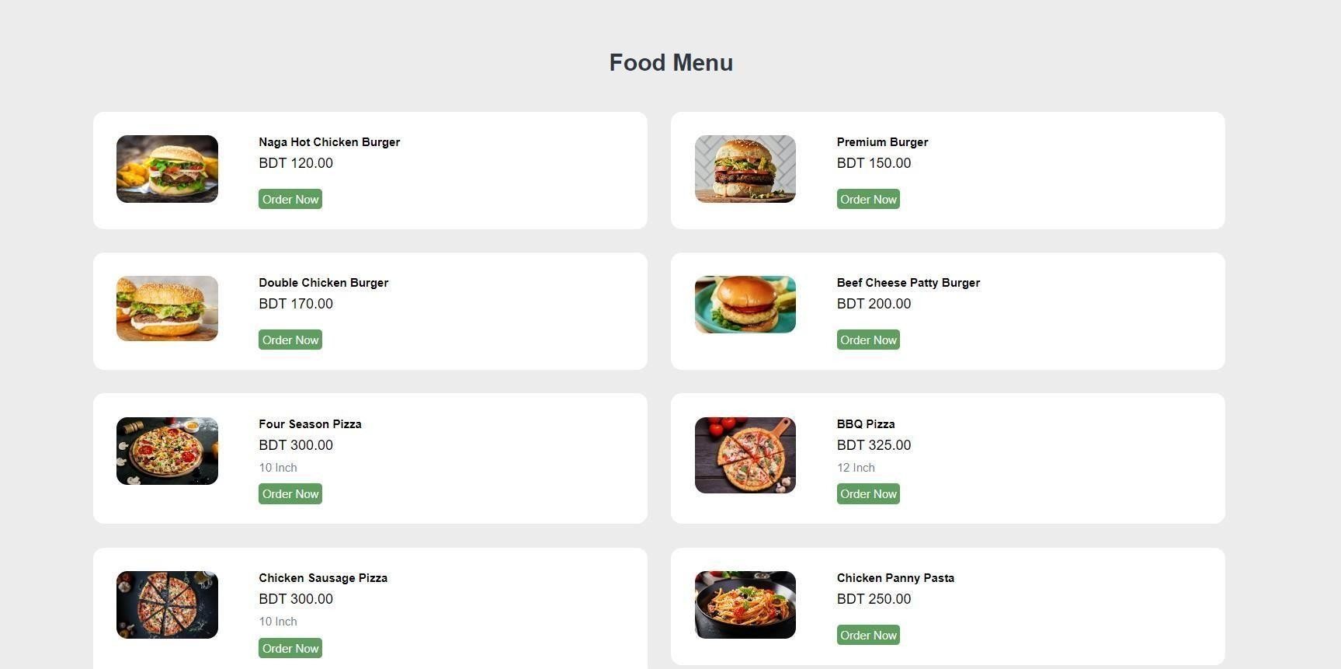

## Result & Discussion

The final output is a complete web based Restaurant Management System, which can be used in any kind of restaurant. This Restaurant Management System can help to manage the Restaurant more effectively, efficiently and smoothly. This is more secured and there will be speedy and well ordered authentication procedure for the maintenance of records. At present time, in this technology based world, people likes and wants everything to be smooth and efficient through the use of data and information. In this perspective, our Restaurant Management System can be an ideal platform for the users. Its user friendly interface can help the customers to find his/her desired menu item and place order with a few click. Customers can easily place an online order by browsing the menu options, pick what they want sitting at home. And can also receive their food in a short period of time.

## Application

* Restaurants, takeaways, and businesses that sell food to go profit from internet meal ordering software designed specifically for them. Customers like the ease of online meal ordering,

which is why it is expanding quickly. Expand your sales channels by downloading our online food ordering application.

* Through this food ordering website, customers may place orders from their computers, tablets, and cellphones. They can look through your menu options, choose what they want, and submit

an order online. Internet-based payment will also be accepted. Meals can be picked up in person or delivered to customers.

* There are many benefits to using an online food ordering app or a restaurant ordering app, including reduced labor expenses, fewer walk-away customers, and shorter wait times. This

restaurant's online ordering system is intended for independent and multi-location chains that offer food to go, including eateries, fast food outlets, take-out, and other catering services.

* Putting your company online will enable you to generate a lot more revenue, which will

enhance your marketability.

## Advantages

* + - It is quick, simple, and pleasant.
    - Managing an online menu is easier.
    - Access is only a click away.
    - Less work for you.

## Limitations of the System

The system has certain other restrictions as well. There are only a few basic functions in the system's shopping cart, and it cannot be extensively customized. Additionally, practically all of the functionality of the application, including validation, is handled by server-side programming. It increases the server's workload, especially when a large number of users access the program. This issue can be resolved by using client-side languages, such as JavaScript or HTML 5, to check data. Additionally, the order model has been created.

# Conclusion & Future Work

## Conclusion

Restaurant Management System is a web-based technology that aids the restaurant industry in carrying out tasks effectively and efficiently. It aids in managing cash flow for managers. Managers can view analytics data to assess company growth. The manager can control orders and employee schedules by using this system. The full complement is a restaurant management system. It provides access to the Online Order platform, third-party connectors software, and comprehensive CRM solution, which together cover a sizable portion of your restaurant's requirements. They are not the outdated hardware and software sets for restaurants that were previously offered. They are the hottest things around, smooth, manageable, inexpensive, and quick.

In the "Online Food Ordering Project," we made every effort to meet all the demands of the restaurant. Because it is straightforward and adaptable, the project is successful. The biggest benefit of my project is that it draws plenty of users because of its simplicity. A novice user may operate it with ease. Any type of restaurant can utilize our software. By automating meal ordering, billing, and inventory control, the restaurant management system assists the restaurant manager in managing the restaurant more successfully and efficiently. The system handles the transaction and stores the data produced. These data will be used to create reports that assist the restaurant manager in making wise business decisions. For example, the manager can decide whether more waiters, delivery men, delivery carts, and cooks are needed based on how many clients will be present during a specific time period. When this project is finished, all security concerns will be resolved. Additionally, a quick and secure authentication process will be used for record maintenance. Because it automatically pulls information about a consumer from the database on subsequent visits, data entry is quick and easy. As a result, our program will undoubtedly succeed in replacing the antiquated manual way of storing secure information. The work plan also specifies the specific

front end and back end characteristics of the technology being used in the project. Future project goals and its scope have been elaborated.

## Future Work

Each project should pay close attention to future development because it contains the system's most recent features. It lessens software issues and defects. It develops a close relationship with customers based on their comments or preferences. Developer will incorporate certain dynamic elements that are briefly described below into my restaurant management system.

Reporting module with real time mechanism.

* + 1. Modern architecture with smooth transitions.
    2. System for email and mobile confirmation.
    3. Selling Point

# REFERENCE

1. *Database Programming with JDBC and Java by O'Reilly*
2. *Java and Software Design Concepts by Apress*
3. *<https://www.tutorialspoint.com/java/>*
4. *<http://www.javatpoint.com/java-tutorial>*
5. *<https://docs.oracle.com/javase/tutorial/>*